Final Project Report

Exploring Object Detection Its Applications

Ishan Khanka (IK1304)

Avantika Singh (AS13594)

**INDEX**

Introduction

Problem Statement and Project Overview

Related work

Dataset

Steps (How does it work ?)

Demo

Evaluation

Discussion (e.g., challenges, lessons learned, etc.)

Conclusion and future work

**Introduction:**

O[bject detection](https://analyticsindiamag.com/what-is-the-difference-between-image-classification-object-detection-techniques/) is one of the domains that has brought about a rapid and revolutionary change in the field of computer vision and deep learning. It deals with identifying and locating objects of certain classes in images. When humans look at images or video, we can recognize and locate objects of interest within a matter of moments. The goal of object detection is to replicate this intelligence using a computer. Given a set of object classes, object detection helps in determining the location and scale of all object instances, if any, that are present in an image.

**Image Classification:** Image classification is where a model can analyze an image and identify the ‘target class’ the image falls under essentially answering the question “What is in this picture?”

**Object Localization:** It is used to locate the presence of an object in the image and represent it with a bounding box in the form of (position, height, and width) essentially answering the question “What is it and where it is?”

However, in a real real-life scenario, we need to go beyond locating just one object in a given image. We need systems that are capable of detecting multiple objects in an image and Object Detection provides the means for doing exactly that.

**Object Detection:** Object Detection algorithms act as a combination of Image classification and Object localization. It takes an image as input and produces one or more bounding boxes with the class label attached to each bounding box. Object detection models are capable enough to deal with multi-class classification, object localization as well as with objects with multiple occurrences.

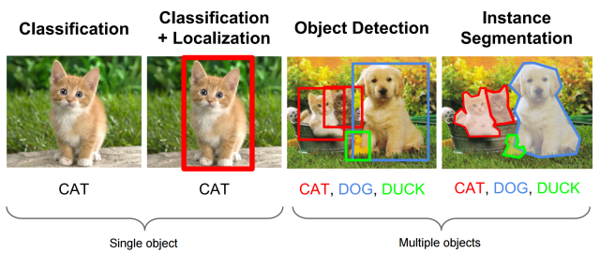

**Problem Statement and Project Overview:**

* Our objective is to build a model for object detection using image datasets.
* We plan to run the model on GPU’s available on cloud platforms and Baremetal.
* We seek to analyze/compare their relative performance on these different platforms based on the execution time as well as the model’s loss function thereby accounting for both the cloud and machine learning aspects of this course.
* Furthermore, we will be creating a web application that users could use to detect common objects or different types of blood cells in images uploaded by them.





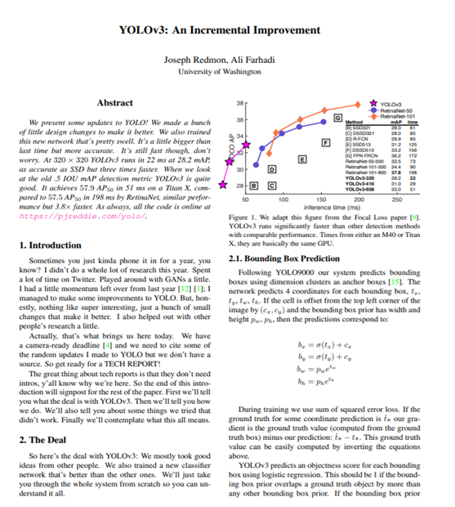**Related work:**

For the purpose of our project we found the following resources to be extremely helpful**:**

**Yolo v3 :**

[**https://pjreddie.com/darknet/yolo/**](https://pjreddie.com/darknet/yolo/)

**Papers With Code:**

[**https://paperswithcode.com/method/yolov3**](https://paperswithcode.com/method/yolov3)

**YOLO v3-Tiny: Object Detection and Recognition using one stage improved model**[**https://ieeexplore.ieee.org/document/9074315**](https://ieeexplore.ieee.org/document/9074315)

**Towards DataScience**

[**https://towardsdatascience.com/yolo-v3-object-detection-53fb7d3bfe6b**](https://towardsdatascience.com/yolo-v3-object-detection-53fb7d3bfe6b)

**Models Used:**

YOLO (“You Only Look Once”) is an effective real-time object recognition algorithm, first described in the seminal 2015 paper by Joseph Redmon.

Giving us an opportunity to analyze how the number of layers impacts the performance of the model, we used the following two versions of YOLO for the experiment design:

* Yolo v3
* Tiny-Yolo v3

**1. Yolov3:**

**Yolov3 Network Architecture:**

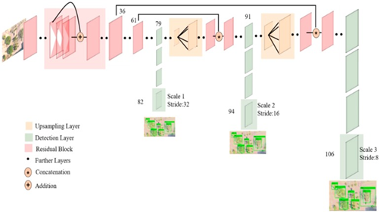YOLO v3 uses a variant of Darknet, which originally has a 53-layer network trained on ImageNet. For the task of detection, 53 more layers are stacked onto it, giving us a 106 layer fully convolutional underlying architecture for YOLO v3.

The most salient feature of v3 is that it makes detections at three different scales by down sampling the dimensions of the input image by 32, 16 and 8 respectively.

The first detection is made by the 82nd layer. Then, the second detection is made by the 94th layer and the final at the 106th layer.

**Feature Extraction and Detection:**

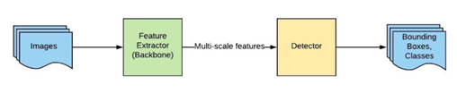The whole system can be divided into two major components:

* Feature Extractor
* Detector

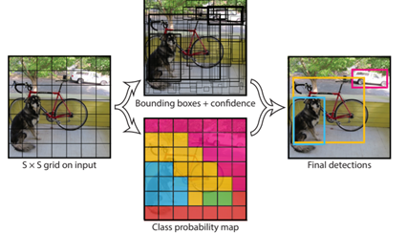

When a new image comes in, it goes through the feature extractor first so that we can obtain feature embeddings at three (or more) different scales. Then, these features are fed into three (or more) branches of the detector to get bounding boxes and class information.

We take an image and split it into an SxS grid, within each of the grid we take m bounding boxes. For each of the bounding box, the network outputs a class probability and offset values for the bounding box. The bounding box having the class probability above a threshold value is selected and used to locate the object within the image.

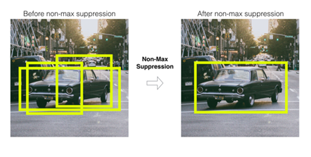With the YOLO algorithm we are not searching for interesting regions in our input image that could potentially contain an object. Instead, we are splitting our image into cells. Each cell is responsible for predicting bounding boxes. Therefore, we arrive at many bounding boxes for one image.

Most of these cells and bounding boxes will not contain an object.

Therefore, we use the value of pc- the probability that there is an object in the bounding box to remove/prune bounding boxes with low object probability and with the highest shared area. This process is called **non-max suppression.**

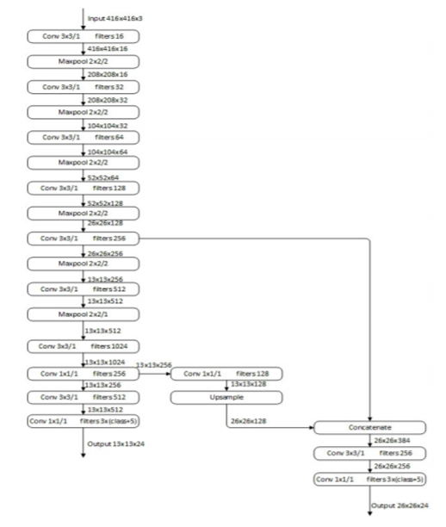**2. Tiny-Yolov3**

The Tiny-yolov3 model is a simplified version of the YOLOV3 model.

YOLOV3 uses the architecture of darknet53, and then uses many 1x1 and 3x3 convolution kernels to extract features. Tiny-Yolov3 reduces the number of convolutional layers, its basic structure has only 7 convolutional layers, and then features are extracted by using a small number of 1x1 and 3x3 convolutional layers.

Tiny-Yolov3 uses the pooling layer instead of YOLO V3’s convolutional layer with a step size of 2 to achieve dimensionality reduction.

**Datasets:**

As accuracy was not the focus for the assignment, for testing and performance two different datasets were used, one for common object detection and one for blood cell detection.

* **COCO:**
  + **Dataset Description:**
    - COCO stands for Common Objects in Context
    - There are 330K images (>200K labeled)
    - About 1.5 million object instances
    - 80 object categories
    - 5 captions per image
  + **Object detection for COCO:**

Object detection is breaking into a wide range of industries, with use cases ranging from personal security to productivity in the workplace. Object detection and recognition is applied in many areas of computer vision, including image retrieval, security, surveillance, automated vehicle systems and machine inspection.

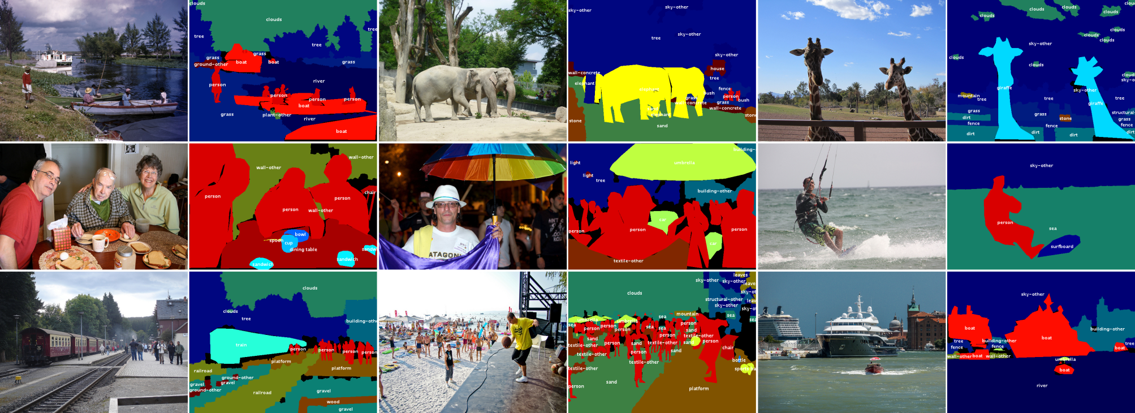

* **BCCD**:
  + **Dataset Description:**
    - 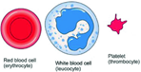BCCD stands for Blood Cell Count and Detection
    - There are 364 images across three classes:
      * WBC (white blood cells)
      * RBC (red blood cells),
      * Platelets.
    - In total, there are 4888 labels across 3 classes
  + **Object Detection for BCCD:**

Counting the number of white blood cells(WBC’s),red blood cells(RBC’s) and platelets in the blood is an important test for evaluating the health of an individual. The lack or excess of any one of these could be the sign of a potential disease and could lead to severe health problems. Traditionally blood cells are counted manually using hemocytometer along with other laboratory equipment and chemical compounds, which is a time-consuming and tedious task. Hence, the use of deep learning-based systems for detection and counting enables us to count blood cells from smear images in less than a second, which is useful for practical applications.

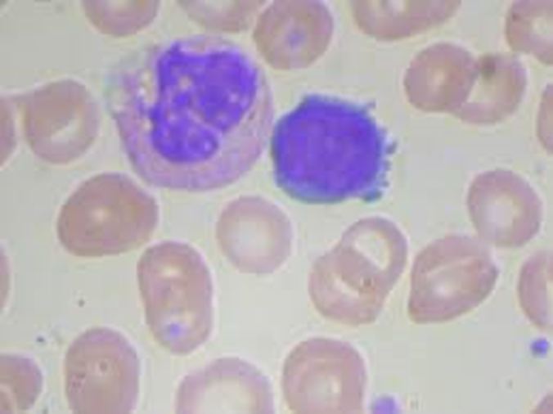

**Steps and Execution:**

1. Steps for Bare metal:

* ssh ik1304@gw.hpc.nyu.edu
* ssh ik1304@prince.hpc.nyu.edu
* Copy code from github to /scratch/ik1304 via winscp
* Get an Interactive node.   
  srun -t10:00:00 --gres=gpu:1 --mem 102400 --pty /bin/bash
* Load module. We are using the stable one.   
  module load python3/intel/3.6.3 cuda/9.0.176 nccl/cuda9.0/2.4.2
* Set up the python virtual environment.   
  mkdir pytorch_env  
  cd pytorch_env  
  virtualenv --system-site-packages py3.6.3  
  source py3.6.3/bin/activate  
  pip3 install <http://download.pytorch.org/whl/cu92/torch-0.4.1-cp36-cp36mlinux_x86_64.whl>  
  pip3 install torchvision  
  cd..  
  pip3 install -r requirements.txt
* Activate the virtual environment.   
  source pytorch_env/py3.6.3/bin/activate
* Execute job with different variations of hyperparameters, for eg:

1. /usr/bin/time -v nvprof python train.py --img 416 --batch 4 --epochs 1 --data bccd.yaml --weights yolov3.pt &> bare_metal_bs4_ep1_lr1.txt
2. /usr/bin/time -v nvprof python train.py --img 416 --batch 8 --epochs 1 --data bccd.yaml --weights yolov3.pt &> bare_metal_bs8_ep1_lr1.txt
3. /usr/bin/time -v nvprof python train.py --img 416 --batch 16 --epochs 1 --data bccd.yaml --weights yolov3.pt &> bare_metal_bs16_ep1_lr1.txt
4. /usr/bin/time -v nvprof python train.py --img 416 --batch 32 --epochs 1 --data bccd.yaml --weights yolov3.pt &> bare_metal_bs32_ep1_lr1.txt

.

.

.

All the different permutations of runs are given in **baremetal run.txt**

2. Execution on Baremetal:

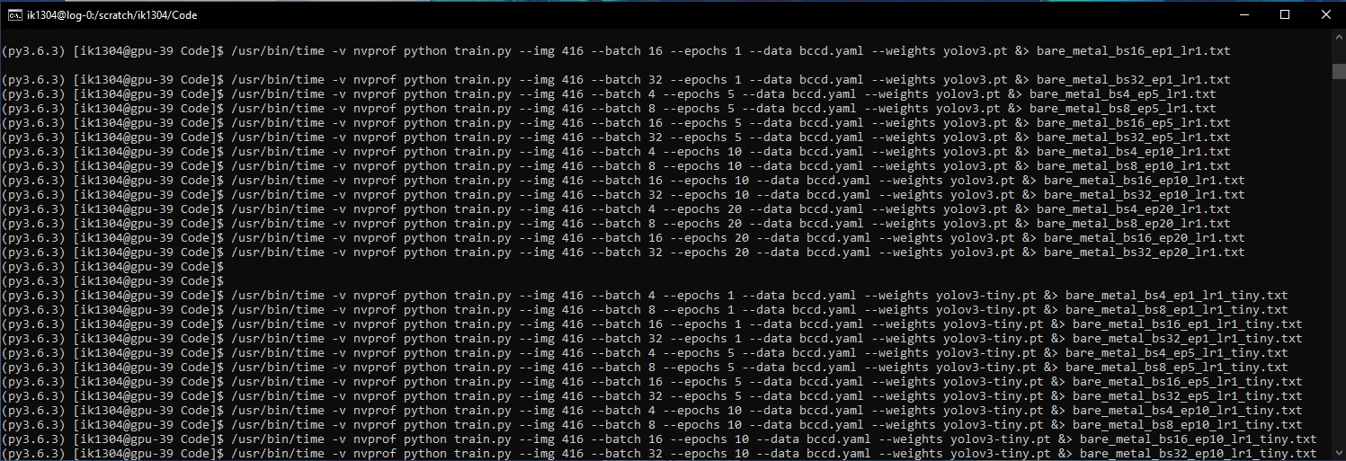

**Note** – Logs for each of the experiment is stored in the root dir under logs/logs-baremetal

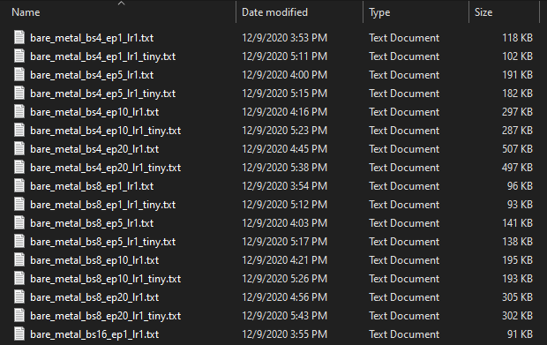

3. Steps for Public Cloud Code:

* Login to Google Colaboratory via <https://colab.research.google.com/notebooks/welcome.ipynb>
* Upload the code containing training_driver.ipynb to the google cloud storage:

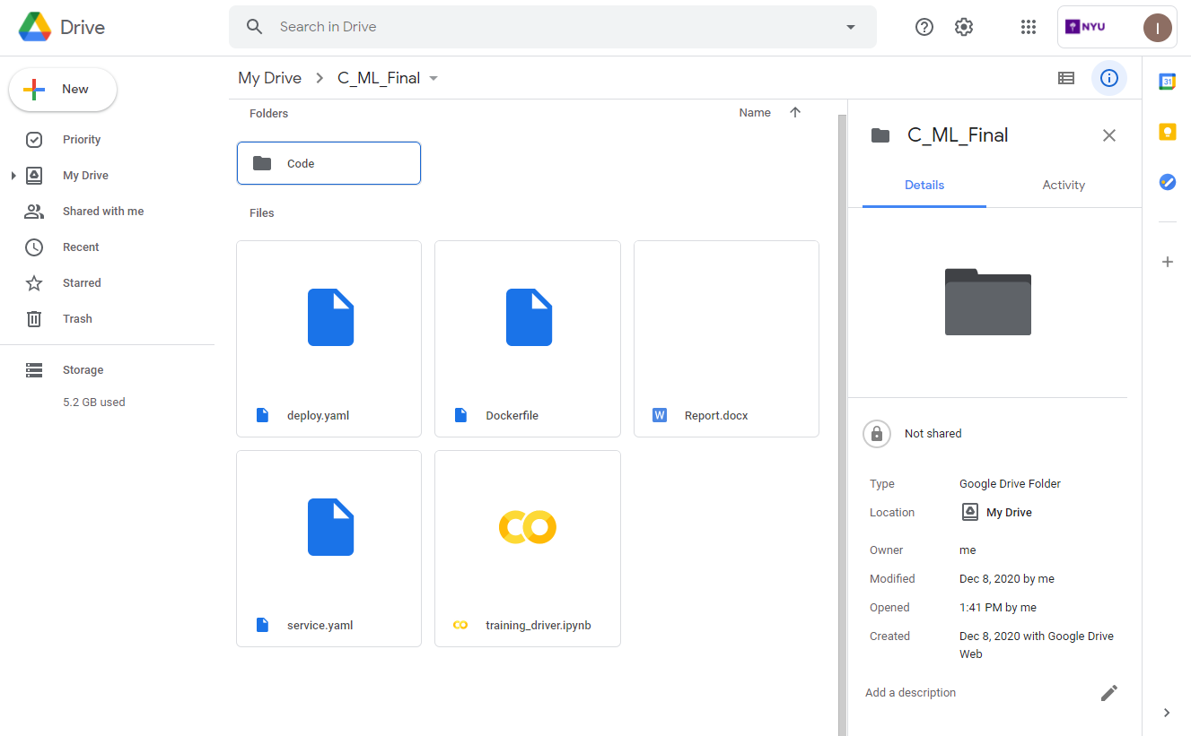

* Authorize Jupyter notebook to access the storage:

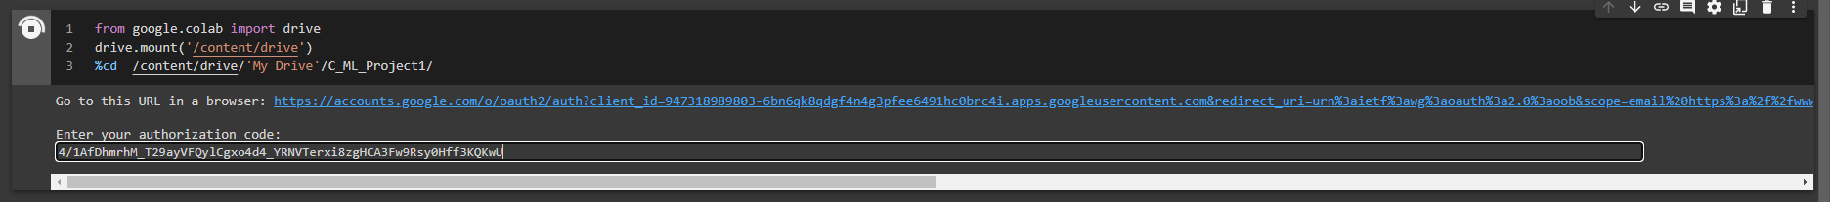

* Training_driver.ipynb has all the necerry code to install dependencies and access the storage

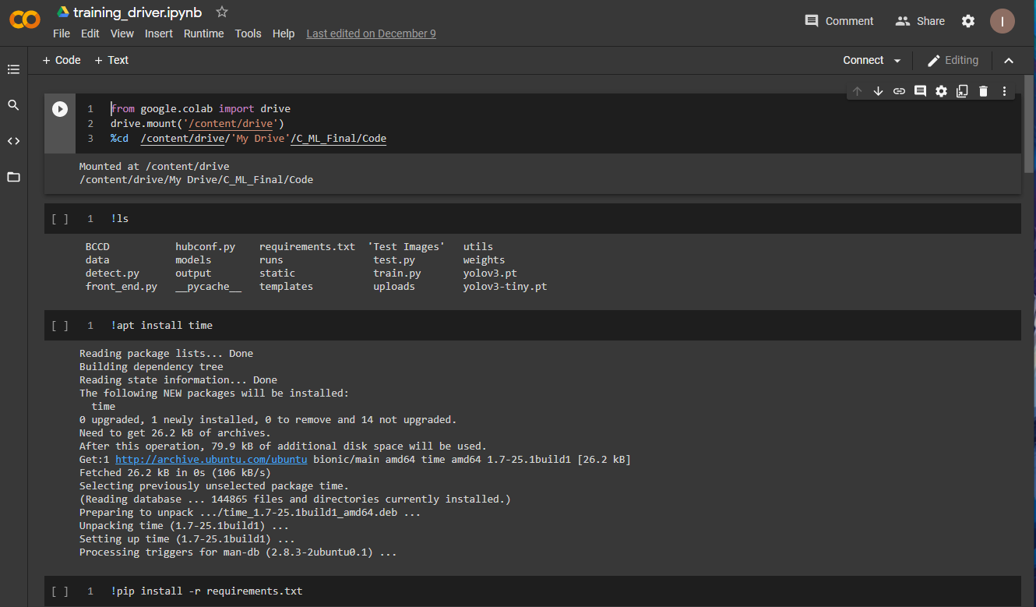

* Before executing the notebook, go to Runtime > Change runtime type> Hardware accelerator> GPU

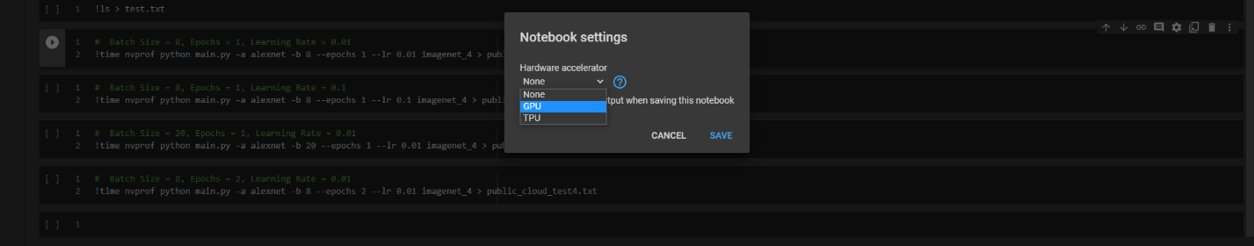

* Run the cells of the notebook.

4. Execution on Cloud Environment :

Run the cells of the notebook. Screenshots below show the code and profiler running:

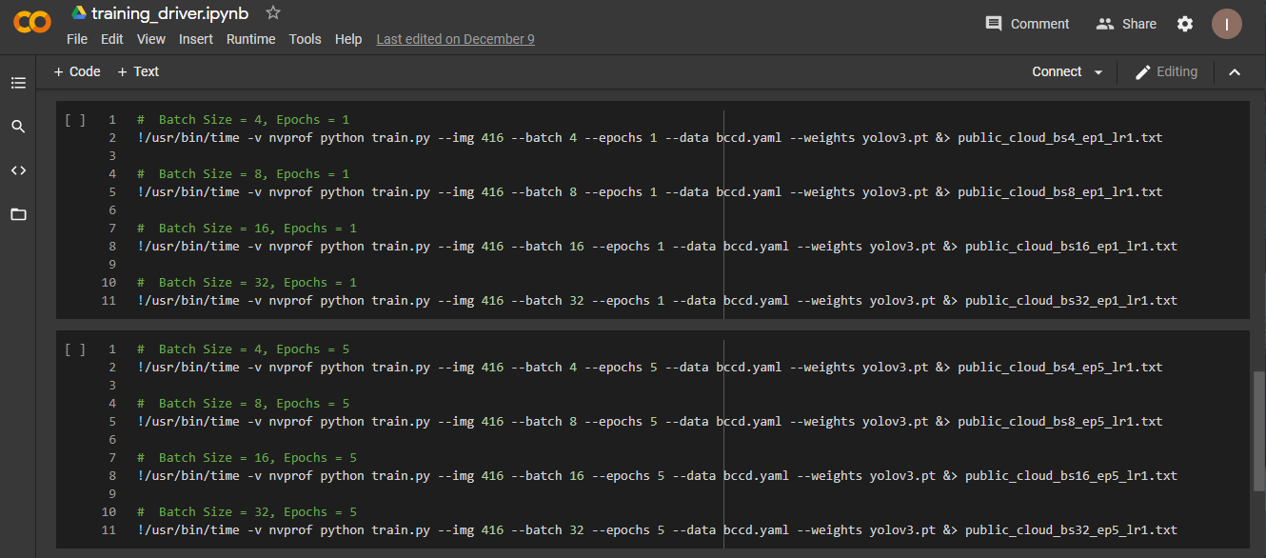

**Note** – Logs for each of the experiment is stored in the root dir under logs/logs-cloud

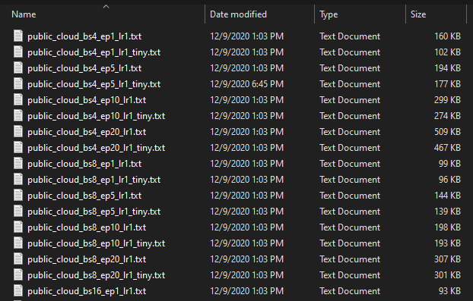

**Demo:**

**The i**[**nference web application can be accessed by going to the following link:**](http://159.122.181.44:32073/)  [**http://159.122.181.44:32073/**](http://159.122.181.44:32073/)

Common Object Detection:

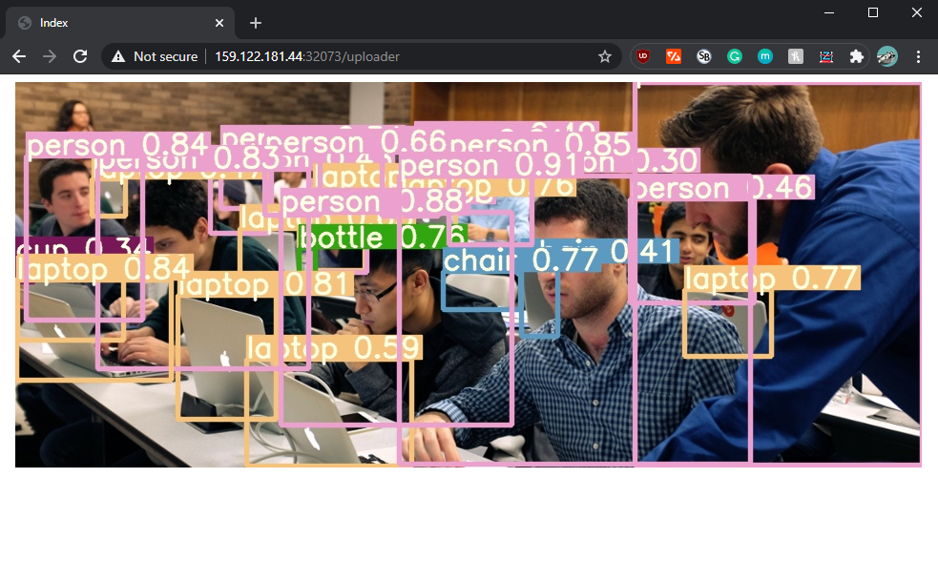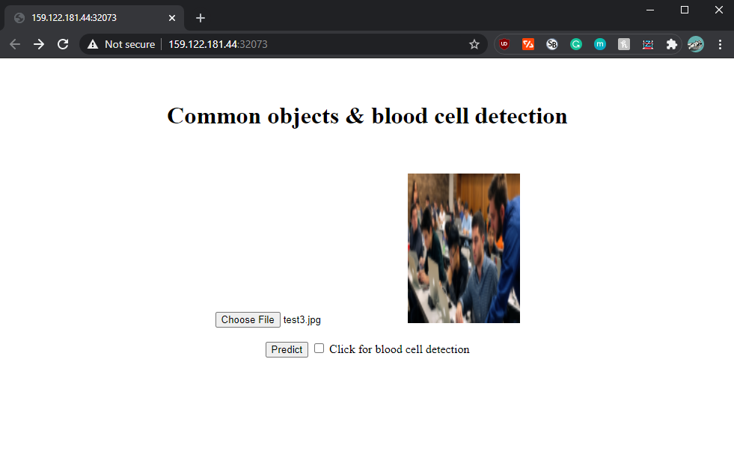

Blood Cell Detection:

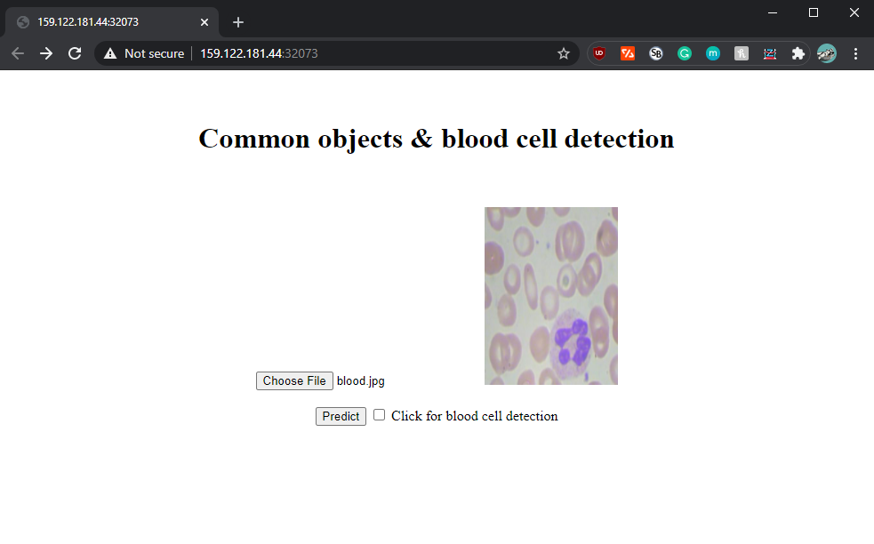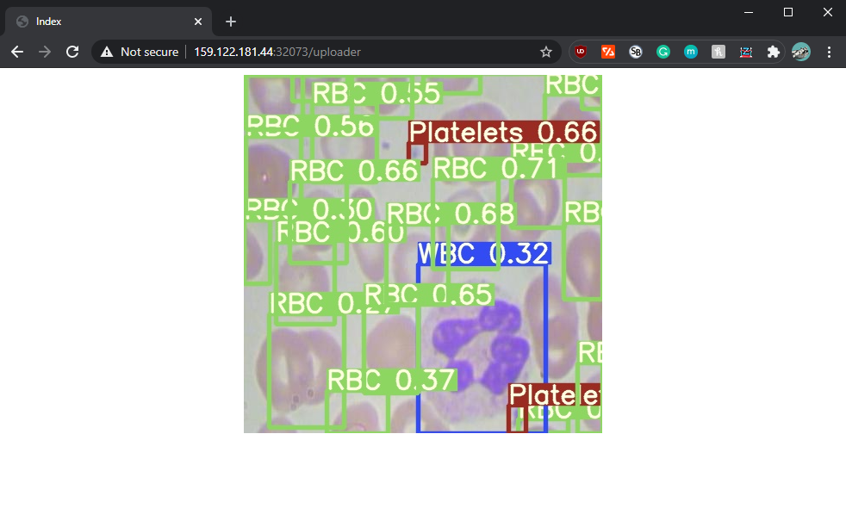

**Evaluation:**

Experiment setup

For training the model we use the following hyperparameter configurations:

Epochs : 1, 5, 10, 20

Batch size : 4, 8,16, 32

Models : YOLO and YOLO Tiny

Execution environment : Cloud - Tesla T4, 15079MB

BareMetal - Tesla P40, 22919MB

Total Experiments: **64**

Metrics for model performance

Precision : tp / (tp + fp) or how many selected items are relevant

Recall : tp / (tp + fn) or how many relevant items are selected

Objectness score : identify if an object is present in the image and the class of the object

Classification score : measure how well the detector identifies the locations and classes of objects during navigation

Profiling

User time (seconds)

Percent of CPU a job got

Maximum resident set size (kbytes)

NVPROF profiling (Avg. time for biggest GPU activity)

Next four pages contain the metrics for 64 experiments.

Cloud : Tesla T4, 15079MB

LR : 0.2 – 0.01

Model : YOLO

|  |  |  |  |  |  |  |  |  |  |
| --- | --- | --- | --- | --- | --- | --- | --- | --- | --- |
| Batch size | Epoch | User time (seconds) | Percent of CPU this job got | Maximum resident set size (kbytes) | NVPROF  Avg time for Biggest GPU activity* | Precision | Recall | Objectness  Score | Classification  Score |
| 4 | 1 | 59.68 | 20% | 8078296 | 216.13us | 0 | 0 | 0.1282 | 0.03834 |
| 4 | 5 | 219.07 | 124% | 8127668 | 209.45us | 0.1041 | 0.3146 | 0.1443 | 0.01785 |
| 4 | 10 | 412.60 | 124% | 8145492 | 228.89us | 0.4084 | 0.9464 | 0.1257 | 0.01051 |
| 4 | 20 | 800.69 | 125% | 8249352 | 209.24us | 0.5478 | 0.9803 | 0.115 | 0.003764 |
| 8 | 1 | 43.49 | 106% | 8058616 | 404.16us | 0 | 0 | 0.1263 | 0.03874 |
| 8 | 5 | 157.79 | 107% | 8037768 | 403.41us | 0.1001 | 0.1917 | 0.1548 | 0.02282 |
| 8 | 10 | 288.97 | 98% | 8132920 | 406.81us | 0.4042 | 0.51 | 0.137 | 0.01418 |
| 8 | 20 | 557.73 | 107% | 8145180 | 408.72us | 0.5477 | 0.9834 | 0.1197 | 0.005045 |
| 16 | 1 | 39.03 | 104% | 8026880 | 831.73us | 0 | 0 | 0.1227 | 0.03905 |
| 16 | 5 | 127.21 | 100% | 8103536 | 793.00us | 0.1392 | 0.002035 | 0.1618 | 0.02621 |
| 16 | 10 | 232.83 | 91% | 8168672 | 790.48us | 0.09563 | 0.3475 | 0.1449 | 0.0165 |
| 16 | 20 | 430.76 | 89% | 7937896 | 787.32us | 0.4309 | 0.9302 | 0.126 | 0.01053 |
| 32 | 1 | 36.94 | 96% | 8188700 | 1.5461ms | 0 | 0 | 0.121 | 0.03939 |
| 32 | 5 | 100.20 | 91% | 8167160 | 1.5375ms | 0 | 0 | 0.1598 | 0.02832 |
| 32 | 10 | 188.09 | 82% | 8247332 | 1.5436ms | 0.08012 | 0.2426 | 0.1582 | 0.01984 |
| 32 | 20 | 358.07 | 77% | 8024508 | 1.5376ms | 0.4358 | 0.5017 | 0.1361 | 0.01332 |

* GPU Process Name: turing_s1688cudnn_fp16_128x128_ldg8_wgrad_idx_exp_interior_nhwc_nt_v1

Cloud : Tesla T4, 15079MB

LR : 0.2 – 0.01

Model : YOLO Tiny

|  |  |  |  |  |  |  |  |  |  |
| --- | --- | --- | --- | --- | --- | --- | --- | --- | --- |
| Batch size | Epoch | User time (seconds) | Percent of CPU this job got | Maximum resident set size (kbytes) | NVPROF  Avg time for Biggest GPU activity* | Precision | Recall | Objectness  Score | Classification  Score |
| 4 | 1 | 35.41 | 86% | 7791772 | 493.46us | 0.3333 | 0.000407 | 0.3489 | 0.03383 |
| 4 | 5 | 113.99 | 142% | 7872560 | 519.20us | 0.1224 | 0.2856 | 0.3949 | 0.01768 |
| 4 | 10 | 211.06 | 148% | 7983268 | 498.96us | 0.4919 | 0.7248 | 0.3522 | 0.01251 |
| 4 | 20 | 403.25 | 149% | 8031684 | 576.02us | 0.4631 | 0.9638 | 0.3704 | 0.004965 |
| 8 | 1 | 31.69 | 118% | 7791604 | 834.39us | 0 | 0 | 0.3443 | 0.03426 |
| 8 | 5 | 89.82 | 135% | 7906188 | 787.11us | 0.07403 | 0.2478 | 0.3863 | 0.02012 |
| 8 | 10 | 159.81 | 140% | 7991160 | 857.89us | 0.3285 | 0.4478 | 0.3554 | 0.01533 |
| 8 | 20 | 305.24 | 144% | 8043184 | 921.07us | 0.3907 | 0.9397 | 0.3734 | 0.007637 |
| 16 | 1 | 31.04 | 121% | 7831888 | 1.2530ms | 0 | 0 | 0.3388 | 0.03472 |
| 16 | 5 | 72.78 | 120% | 7971648 | 1.0918ms | 0.06874 | 0.2362 | 0.3887 | 0.02186 |
| 16 | 10 | 133.78 | 132% | 8068780 | 612.43us | 0.09037 | 0.3128 | 0.3535 | 0.01665 |
| 16 | 20 | 254.68 | 136% | 8055140 | 1.1414ms | 0.3875 | 0.7995 | 0.3815 | 0.01247 |
| 32 | 1 | 30.89 | 121% | 7997356 | 971.44us | 0 | 0 | 0.3311 | 0.03511 |
| 32 | 5 | 67.87 | 123% | 8032080 | 818.98us | 0.1123 | 0.06577 | 0.4088 | 0.02338 |
| 32 | 10 | 125.99 | 140% | 8166852 | 792.54us | 0.06413 | 0.2804 | 0.3506 | 0.01776 |
| 32 | 20 | 229.88 | 138% | 8271416 | 1.7303ms | 0.3208 | 0.4627 | 0.3851 | 0.01511 |

*GPU Process Name: turing_s1688cudnn_fp16_128x128_ldg8_wgrad_idx_exp_interior_nhwc_nt_v1

BareMetal : Tesla P40, 22919MB

LR : 0.2 – 0.01

Model : YOLO

|  |  |  |  |  |  |  |  |  |  |
| --- | --- | --- | --- | --- | --- | --- | --- | --- | --- |
| Batch size | Epoch | User time (seconds) | Percent of CPU this job got | Maximum resident set size (kbytes) | NVPROF  Avg time for Biggest GPU activity* | Precision | Recall | Objectness  Score | Classification  Score |
| 4 | 1 | 64.36 | 87% | 4446340 | 536.73us | 0 | 0 | 0.1311 | 0.03814 |
| 4 | 5 | 237.12 | 98% | 4536808 | 535.41us | 0.09708 | 0.3486 | 0.1499 | 0.01811 |
| 4 | 10 | 441.65 | 99% | 8638968 | 534.50us | 0.3902 | 0.9296 | 0.1257 | 0.01085 |
| 4 | 20 | 860.14 | 99% | 16842640 | 535.31us | 0.5031 | 0.9835 | 0.1114 | 0.004033 |
| 8 | 1 | 46.49 | 96% | 4530028 | 1.0198ms | 0 | 0 | 0.1361 | 0.03849 |
| 8 | 5 | 164.83 | 98% | 4579324 | 1.0203ms | 0.1114 | 0.1734 | 0.1517 | 0.02264 |
| 8 | 10 | 300.99 | 99% | 5276692 | 1.0207ms | 0.3616 | 0.495 | 0.1387 | 0.01367 |
| 8 | 20 | 563.84 | 99% | 9962264 | 1.0192ms | 0.573 | 0.9807 | 0.112 | 0.005232 |
| 16 | 1 | 37.34 | 94% | 4676540 | 2.0153ms | 0 | 0 | 0.1324 | 0.03895 |
| 16 | 5 | 119.94 | 97% | 4792180 | 2.0123ms | 0.3333 | 0.002409 | 0.1593 | 0.02588 |
| 16 | 10 | 226.52 | 98% | 4894208 | 2.0142ms | 0.08948 | 0.3385 | 0.1476 | 0.01615 |
| 16 | 20 | 416.45 | 99% | 6382660 | 2.0382ms | 0.426 | 0.9488 | 0.1187 | 0.01102 |
| 32 | 1 | 35.80 | 93% | 4905660 | 3.9772ms | 0 | 0 | 0.1301 | 0.03931 |
| 32 | 5 | 99.48 | 97% | 4998552 | 3.9899ms | 0 | 0 | 0.1567 | 0.02835 |
| 32 | 10 | 187.84 | 98% | 5194808 | 3.9758ms | 0.07667 | 0.2491 | 0.1617 | 0.01912 |
| 32 | 20 | 349.26 | 98% | 5261972 | 3.9723ms | 0.4492 | 0.5051 | 0.1269 | 0.01403 |

* GPU Process Name: maxwell_fp16_scudnn_winograd_fp16_fp32_128x128_ldg1_ldg4_tile228n_nt

BareMetal : Tesla P40, 22919MB

LR : 0.2 – 0.01

Model : YOLO Tiny

|  |  |  |  |  |  |  |  |  |  |
| --- | --- | --- | --- | --- | --- | --- | --- | --- | --- |
| Batch size | Epoch | User time (seconds) | Percent of CPU this job got | Maximum resident set size (kbytes) | NVPROF  Avg time for Biggest GPU activity* | Precision | Recall | Objectness  Score | Classification  Score |
| 4 | 1 | 31.41 | 97% | 4138872 | 307.62us | 0 | 0 | 0.3455 | 0.03378 |
| 4 | 5 | 117.00 | 99% | 4259288 | 297.86us | 0.1039 | 0.3165 | 0.379 | 0.01791 |
| 4 | 10 | 216.31 | 99% | 4466392 | 310.17us | 0.415 | 0.752 | 0.388 | 0.01168 |
| 4 | 20 | 393.42 | 99% | 7143760 | 313.74us | 0.4289 | 0.969 | 0.3633 | 0.005112 |
| 8 | 1 | 27.35 | 98% | 4255216 | 520.55us | 0 | 0 | 0.338 | 0.0341 |
| 8 | 5 | 84.10 | 99% | 4376384 | 520.37us | 0.07189 | 0.2482 | 0.3741 | 0.0204 |
| 8 | 10 | 155.67 | 99% | 4551084 | 544.44us | 0.1691 | 0.354 | 0.39 | 0.01529 |
| 8 | 20 | 292.14 | 99% | 4871752 | 558.41us | 0.4673 | 0.9108 | 0.367 | 0.007233 |
| 16 | 1 | 26.23 | 98% | 4487624 | 653.85us | 0 | 0 | 0.3315 | 0.03449 |
| 16 | 5 | 69.10 | 99% | 4599892 | 595.89us | 0.07061 | 0.2212 | 0.3747 | 0.02196 |
| 16 | 10 | 125.14 | 99% | 4770032 | 585.13us | 0.08782 | 0.2987 | 0.3832 | 0.01689 |
| 16 | 20 | Job Failed | Job Failed | Job  Failed | Job  Failed | Job  Failed | Job Failed | Job  Failed | Job  Failed |
| 32 | 1 | 28.16 | 98% | 4626496 | 1.4311ms | 0 | 0 | 0.3231 | 0.0349 |
| 32 | 5 | 64.06 | 99% | 4804504 | 1.2067ms | 0.1158 | 0.05495 | 0.3911 | 0.02353 |
| 32 | 10 | 112.38 | 99% | 4931232 | 1.1705ms | 0.05975 | 0.3012 | 0.3855 | 0.0181 |
| 32 | 20 | 207.22 | 99% | 5136484 | 1.1501ms | 0.3804 | 0.4844 | 0.3772 | 0.01412 |

*GPU Process Name: maxwell_fp16_scudnn_winograd_fp16_fp32_128x128_ldg1_ldg4_tile228n_nt

Inferences:

For easier understanding, we have divided it into two parts:

Inferences regarding the Model

* Yolo Tiny trains faster irrespective of training platform (cloud or bare metal)
  + Inference: Lesser layers in Yolo tiny
* Both models reach higher objectness score for batch size 32 irrespective of the number of epochs
  + Inference: Move inclusive dataset (containing all the classes)
* Higher precision or recall
  + Inference:
    - For Blood Cell detection - recall is a better as our priority is how many relevant items are selected
    - For common object detection - precision is better as our priority is how many selected items are relevant

Inferences regarding the Execution Environment:

* More consistent metrics for use of resources in bare metal for specific batch size
  + Inference: Due to no sharing of resources on bare metal
* Diff in time and way of handling same matrix multiplication while training – GPU in Cloud is faster:
  + Inference:
    - Different architecture of GPU (Maxwell – bare metal vs Turing - cloud)
    - Cloud give easy and faster access to latest (Sep 2018 vs Sep 2016) without maintenance costs
* Higher CPU usage in cloud
  + Inference: More movement of data in cloud as the data was streamed to and from other storage

**Discussion:**

Usability – user experience

|  |  |  |
| --- | --- | --- |
| Sr.no | Baremetal | Public Cloud |
| 1. | Requires access to specialized tools like WinSCP and SSH clients to transfer code / data to the server | Most of the cloud providers has intuitive and easy ways to upload code / data |
| 2. | User is responsible for solving dependencies of tools and libraries for the code to work | Most of the clouds have versatile collection and versions of libraries that get assigned automatically according to the code |
| 3. | Availability of GPU due to multiple active users is a problem | Additional GPU can be easily provisioned with a single click |
| 4. | Fixed resource allocation like memory and disk, which causes waste of resources due to idling | Automatic scaling of resources according to need |

Other challenges and lessons learned

* Deploying object detection models generally takes A LOT of memory and computation power, especially on machines we use daily.
* Used Yolo tiny for inference due to faster and compact size
* Running 64 experiments and analyzing the results was a little tedious and time consuming.
* Working our way through the Yolo framework required significant research.
* In order to use the model on a custom dataset we had to figure a way to generate labels for the BCCD dataset.
* All object detection frameworks continue to struggle with small objects, especially those bunched together with partial occlusions.

**Conclusion and future work:**

Conclusion

* Cloud provides access to the latest and faster GPU but BareMetal provides better reservation of resources.
* Tiny YOLO trains faster, gives nearly same performance with smaller model size
* We were successful in creating a web application which can be used to detect both cases with just a flick of checkbox
* The results discussed showed good insights for:
  + Model training – Which metrics matters and what should be the hyperparameters for best accuracy
  + Execution environment – How training the same application in different environments shows a stark difference:
    - model evaluation and experimentation – BareMetal
    - Deployment with low maintenance cost – Cloud

Future work

* More in-depth evaluation of logs and model collected for each experiment ( 10 GB of data & 64,000 lines of logs)
* Front end with option to train with user provided hyperparameters
* Add form fields where the user can key in hyperparameters like batch size, learning rate, epochs etc.
* This would allow user to train and then immediately test out the performance of the model
* Instead of multi model approach, create single model for both use cases (blood cell and common object detection)
* Make use of image segmentation for better localization of objects